INDIAN TOURISM

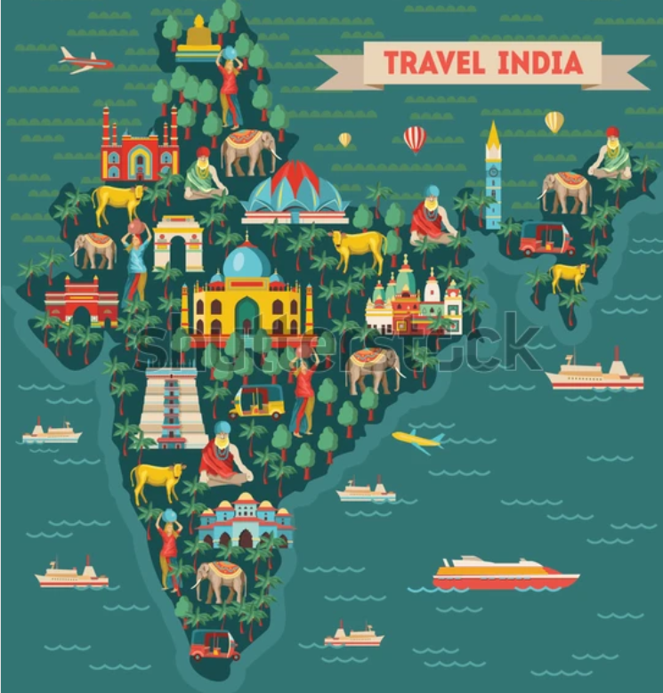

Presented by:

* Ananya Singh
* Anushka Saha
* Shubhadip Mondal
* Monalisa Mondal
* Ramisha Aktar
* Rajdeep Debnath

India is one of the world's most popular and diverse tourist destinations, attracting millions of visitors annually due to its rich cultural heritage, natural beauty, historical landmarks, and vibrant traditions. Here’s a comprehensive look at the tourism industry in India, highlighting key trends, attractions, challenges, and the overall impact on the economy.

**1. Tourism Statistics and Economic Impact**

* **Tourism's Contribution to GDP**: In 2023, the tourism sector contributed about 6.8% to India’s GDP, making it an important driver of the economy.
* **Foreign Tourist Arrivals (FTAs)**: India received over 10 million foreign tourists in 2023, with popular destinations including Delhi, Agra, Rajasthan, Kerala, Goa, and the Himalayan region.
* **Domestic Tourism**: Domestic tourism is a major part of the industry, with millions of Indians traveling within the country. With the rise of middle-class incomes, domestic tourism continues to grow.

**2. Popular Tourist Destinations**

India offers an incredible variety of experiences for tourists. Some of the top destinations include:

* **Historical and Cultural Sites**:
  + **Taj Mahal, Agra**: One of the most famous landmarks in the world, attracting millions of international tourists each year.

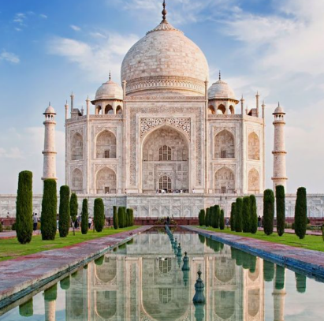

* + **Jaipur and Rajasthan**: Known for its forts, palaces, and rich royal heritage.
  + **Banaras**: The spiritual heart of India, attracting pilgrims and tourists interested in Hindu culture.
  + **Qutub Minar, Delhi** and **Red Fort**: Historic Islamic architecture and UNESCO World Heritage Sites.

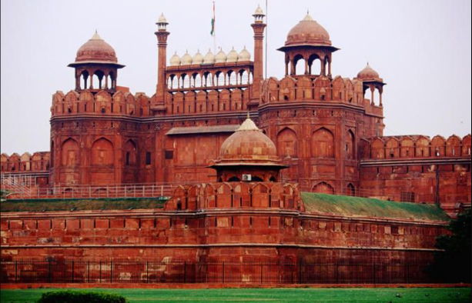

* **Natural Attractions**:

**Himalayas**: Adventure tourism, including trekking, mountaineering, and spiritual retreats, is popular in states like Himachal Pradesh, Uttarakhand, and Jammu & Kashmir.

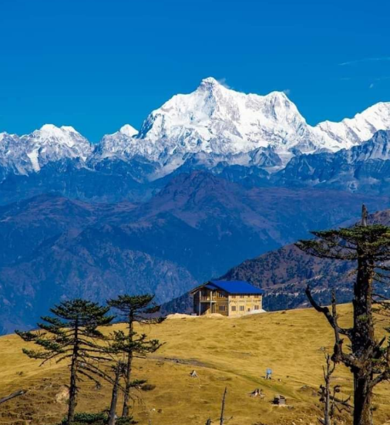

* + **Kerala Backwaters**: A serene and unique experience in the state of Kerala, with houseboats cruising through scenic lakes and rivers.
  + **Goa**: Famous for its beautiful beaches, vibrant nightlife, and Portuguese-influenced architecture

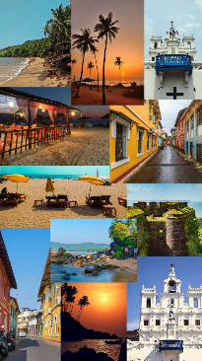.

* + **Ranthambore National Park**: Known for tiger sightings and other wildlife, making it a top eco-tourism destination.
* **Religious Tourism**:
  + **Temples and Pilgrimages**: India is home to some of the holiest places for Hindus, Buddhists, Sikhs, and Muslims. Prominent pilgrimage sites include:
    - **Vaishno Devi (Jammu & Kashmir)**
    - **Golden Temple (Amritsar)** 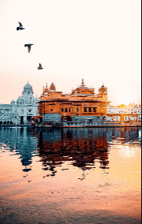
    - **Bodh Gaya (Bihar)**, the site where Buddha attained enlightenment
    - **Banaras(Uttar Pradesh)**

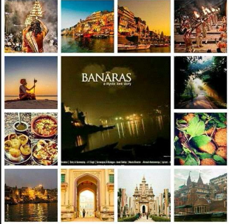

* + - **Ajmer Sharif Dargah** (Rajasthan)
    - **Tirupati (Andhra Pradesh)**

**3. Trends in Indian Tourism**

* **Medical Tourism**: India is becoming a major hub for medical tourism, particularly in cities like Delhi, Mumbai, and Bengaluru. With world-class healthcare facilities at affordable prices, tourists come for treatments ranging from elective surgeries to wellness retreats.
* **Adventure Tourism**: The rise of adventure sports like trekking, paragliding, white-water rafting, and rock climbing is making regions like Himachal Pradesh, Uttarakhand, Ladakh, and Sikkim popular with adventure enthusiasts.

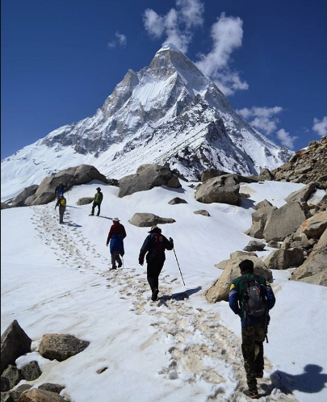 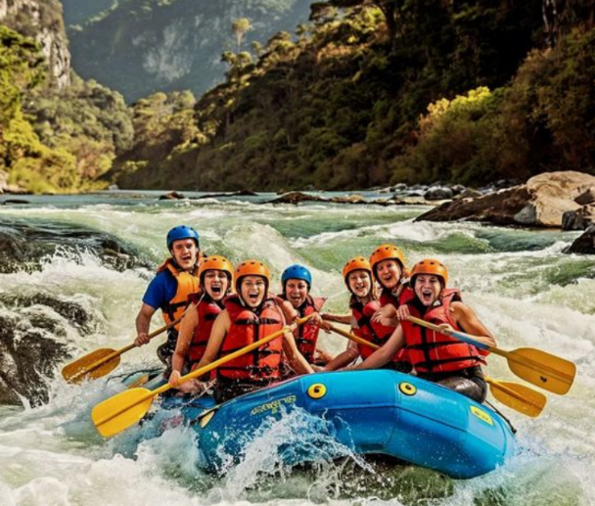

* **Culinary Tourism**: India’s diverse cuisine has also attracted food tourists, with regions like Kerala, Punjab, and Kolkata offering unique local food experiences.

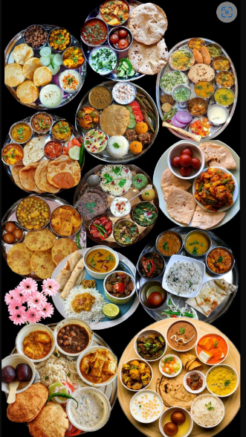

* **Ecotourism and Sustainable Travel**: As environmental consciousness grows, travelers are becoming more focused on eco-friendly options. Destinations like Coorg, Sikkim, and Kerala promote sustainability in tourism.

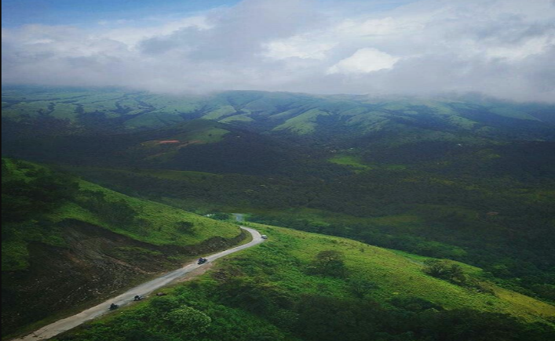

**4. Infrastructure and Development**

* **Airports and Connectivity**: India has a growing number of international and domestic airports, including the Indira Gandhi International Airport (Delhi), Chhatrapati Shivaji Maharaj International Airport (Mumbai), and Kempegowda International Airport (Bengaluru), all of which play a crucial role in connecting India with the world.
* **Transportation**: India has invested heavily in improving transportation infrastructure, including highways, railways (especially the luxury trains like Maharajas' Express), and metro systems in major cities. The Indian government has launched initiatives like the "Dekho Apna Desh" campaign to encourage domestic travel.

**5. Government Initiatives and Policies**

* **e-Visa Facility**: India has simplified visa processes for citizens of over 160 countries through the e-Visa system, making travel easier.
* **Swadesh Darshan Scheme**: A government initiative focused on the development of tourism infrastructure at various destinations across India.
* **Adopt a Heritage Scheme**: This initiative allows private sector entities to partner with the government to develop and maintain tourist heritage sites.

**6. Post-Pandemic Recovery**

* The COVID-19 pandemic severely impacted the tourism sector globally, and India was no exception. However, the sector has begun to recover, with domestic tourism leading the way. There has been a shift towards "safe travel" and wellness tourism, with more people opting for secluded, nature-based holidays.

**7. Future of Indian Tourism**

* **Digital Transformation**: The use of digital tools and platforms for travel planning, booking, and promoting destinations is expected to continue growing. Virtual tours, digital storytelling, and online travel influencers have become key drivers of tourism.
* **Focus on Sustainable Tourism**: As global awareness of climate change and sustainability grows, India’s tourism industry is focusing on eco-friendly travel experiences, responsible tourism practices, and carbon offsetting initiatives.

**1. Hypothesis on the Impact of Digital Technology on Tourism**

The increasing adoption of digital platforms (e.g., online booking systems, virtual tours, social media influencers) has a positive impact on the growth of both domestic and international tourism in India. With the rise of smartphones and digital technologies, tourists now rely on online platforms for travel planning, bookings, and real-time recommendations. This hypothesis could explore the extent to which digital tools, such as travel apps and influencer marketing, influence tourists' decision-making and increase tourism in lesser-known destinations in India.

**2. Hypothesis on Sustainable Tourism**

The growing awareness of environmental sustainability among global tourists is driving a shift towards eco-friendly and responsible tourism practices in India. As the global focus on sustainability intensifies, tourists are increasingly seeking eco-friendly options. This could include visits to national parks, heritage sites, and destinations promoting sustainable travel practices (e.g., Coorg, Sikkim). This hypothesis would examine whether India’s eco-tourism initiatives (like eco-friendly hotels, waste reduction, and responsible tourism practices) are attracting more tourists.

**3. Hypothesis on Domestic Tourism Growth**

The increasing disposable income and changing lifestyle of India’s middle class will continue to drive the growth of domestic tourism in the country, surpassing foreign tourist arrivals by 2030.. This hypothesis can explore factors like regional preferences, urbanization, and government initiatives to promote local tourism (e.g., "Dekho Apna Desh") in driving domestic travel trends.

**4. Hypothesis on the Role of Heritage and Religious Tourism**

India’s heritage sites and religious tourism will see a significant increase in post-pandemic recovery, driven by a return to spiritual and cultural experience. India has a wealth of heritage and religious tourism potential, with sites like the Taj Mahal, Varanasi, and the Golden Temple.

**5. Hypothesis on the Influence of Infrastructure Development**

The development of new airports, rail li This hypothesis could examine how infrastructure development has affected the number of tourists visiting smaller cities and rural areas.

**6. Hypothesis on Over-Tourism and its Economic Impact**

Over-tourism in popular destinations negatively impacts local economies by causing environmental degradation, loss of cultural authenticity, and unsustainable development. While tourism is a significant contributor to local economies, excessive visitor numbers in certain destinations can lead to environmental and cultural damage.

**9. Hypothesis on the Impact of Government Initiatives**

Government initiatives like the “Incredible India” campaign and the “Swadesh Darshan” scheme have led to a noticeable increase in tourism to lesser-known destinations and cultural heritage sites.

**10. Hypothesis on the Relationship Between Safety Concerns and Tourist Arrivals**

Perceptions of safety and security significantly impact the number of international tourists visiting India, with a decrease in arrivals during periods of political instability or security-related incidents. Safety concerns, such as political instability, natural disasters, and security issues, often affect travel decisions.

**Government Reports and Databases**

* + **Ministry of Tourism (India)**: The Ministry of Tourism regularly publishes annual reports and statistics related to tourism, including data on foreign tourist arrivals (FTAs), tourism revenue, and the performance of different states.
    - **India Tourism Statistics**: Comprehensive statistical data is available through the **Annual Tourism Statistics** and **Tourism Satellite Account (TSA)** reports.
    - **Incredible India** Campaign Reports: Government initiatives and their impact on tourism are often measured and published.
  + **National Sample Survey Office (NSSO)**: The NSSO collects data on domestic tourism through periodic surveys, covering travel preferences, travel distances, and spending patterns.
  + **India Tourism Development Corporation (ITDC)**: The ITDC provides information on the performance of various tourism facilities and services in India.

1. **World Travel & Tourism Council (WTTC) Reports**: Provides global and country-level tourism performance data, including economic contributions, employment figures, and trends.
2. **International Organizations**:
   * **United Nations World Tourism Organization (UNWTO)**: Publishes international tourism data, including India's tourism performance relative to global trends.
   * **World Bank and IMF**: Sometimes publish reports that include tourism-related data as part of economic analysis.
3. **Industry Reports**:
   * **McKinsey & Company** and **Deloitte** publish studies on the tourism industry in India, often including data on growth sectors such as medical tourism, eco-tourism, or luxury travel.

**B. Primary Data Collection**

Primary data is collected directly from tourists, businesses, and local stakeholders through methods like surveys, interviews, and field observations.

1. **Surveys**:
   * **Tourist Surveys**: Direct surveys of tourists (foreign and domestic) at airports, railway stations, hotels, tourist attractions, and transportation hubs to collect data on travel behavior, preferences, spending, and satisfaction.
     + **Exit Polls at Airports and Tourist Sites**: A survey of departing tourists can provide insights into their experiences, destinations visited, and overall satisfaction.
     + **Online Surveys**: Conduct surveys through social media platforms or email, targeting specific tourist groups based on demographics, origin, and preferences.
   * **Interviews with Tourists**: Conduct in-depth interviews with tourists to gather qualitative data on their experiences, motivations, challenges, and satisfaction levels.
   * **Focus Groups**: Group discussions with tourists or tour operators can help explore deeper insights into preferences, trends, and perceptions about tourism in India.
2. **Tourism Business Data**:
   * **Hotel and Resort Data**: Collect information from hotels, resorts, and guesthouses regarding occupancy rates, booking trends, average room prices, and length of stay.
   * **Tour Operators and Travel Agencies**: Data on the types of packages offered, tourist demographics, popular destinations, and emerging trends.
   * **Transportation Providers**: Information on passenger traffic, ticket sales, and travel patterns from airlines, buses, and train operators.
3. **Field Observations**:
   * **Observational Studies at Tourist Destinations**: Researchers can directly observe tourist behavior, interaction with local businesses, and traffic flow in tourist hotspots.
   * **Crowd Management Data**: For crowded destinations (e.g., Taj Mahal, Jaipur, Goa), observe the number of visitors at different times, visitor behaviors, and pressure on local infrastructure.
4. **Social Media Monitoring**:
   * **Sentiment Analysis**: Monitor platforms like Instagram, Twitter, Facebook, and TripAdvisor to gauge tourist sentiment, common complaints, and positive experiences shared by tourists.
   * **Travel Hashtags**: Analyzing travel-related hashtags and geotagged content to determine the popularity of destinations, key tourist activities, and emerging travel trends.

**C. Digital Tools and Platforms**

* **Online Travel Platforms**: Websites like **MakeMyTrip**, **Yatra**, and **Goibibo** can provide data on popular destinations, booking trends, and tourist preferences.
* **Google Analytics**: Used by tourism websites and travel agencies, Google Analytics can provide valuable data on online visitor traffic, popular search terms, and conversion rates related to tourism services.
* **Airbnb and Homestay Data**: Platforms like Airbnb and other homestay services provide insights into the rise of alternate accommodation types and trends in eco-tourism or rural tourism.

**3. Key Data Points to Collect**

* **Demographic Information**: Age, gender, nationality, income group, and travel preferences.
* **Travel Behavior**: Length of stay, purpose of visit (vacation, business, medical, spiritual), and modes of transportation used.
* **Tourist Spending**: Expenditure on accommodation, food, travel, shopping, and activities.
* **Tourism Satisfaction**: Ratings on services like accommodation, food, transportation, and local attractions.
* **Tourist Preferences**: Types of experiences preferred (adventure, cultural, wellness, eco-tourism).
* **Impact on Local Communities**: Data on how tourism affects local businesses, employment, and infrastructure.

**1. Trends in Tourist Arrivals**

**Foreign Tourist Arrivals (FTAs)**

* **Current Trend**: Foreign tourist arrivals to India have been steadily increasing over the last decade, with a slight dip during the COVID-19 pandemic. Data from the **Ministry of Tourism** indicates a recovery in international tourism, with over 10 million foreign tourists visiting India in 2023.
* **Key Observations**:
  + **Popular Source Countries**: The top countries contributing to FTAs to India include the United States, the United Kingdom, Canada, Germany, and Australia, largely due to cultural, historical, and medical tourism.
  + **Seasonal Fluctuations**: Foreign tourist arrivals tend to peak during the winter months (October to March) when the weather is most favorable, particularly in North India.
  + **COVID-19 Impact**: While the pandemic caused a sharp decline in 2020, recovery post-2022 is evident, especially as international flights resume and COVID restrictions ease.
* **Conclusion**: International tourism is rebounding, with significant growth potential in niche segments like medical tourism, adventure tourism, and religious tourism.

**Domestic Tourism**

* **Current Trend**: Domestic tourism in India has surged, especially post-pandemic, driven by an increased interest in local travel due to safety concerns and financial constraints.
* **Key Observations**:
  + **Popular Destinations**: Key domestic tourist hubs include Rajasthan, Kerala, Goa, Himachal Pradesh, and Uttarakhand. Regional tourism is also on the rise, with tourists exploring lesser-known destinations.
  + **Increased Spending**: With the rise of the middle class and a younger demographic seeking affordable leisure options, spending in domestic tourism is increasing, particularly on experiences like wellness retreats and adventure tourism.
  + **Government Initiatives**: Campaigns like "Dekho Apna Desh" are contributing to the growth of domestic tourism by promoting unexplored destinations.
  + **2. Tourist Demographics**

**3. Tourism Revenue**

* **Current Trend**: The tourism sector contributes about 6.8% to India's GDP. The economic impact is most significant in states heavily reliant on tourism, such as Rajasthan, Goa, and Kerala.
* **Key Observations**:
  + **High-revenue States**: States like Delhi, Goa, Kerala, Rajasthan, and Uttar Pradesh generate the highest revenue from tourism. Goa, with its beach tourism, and Rajasthan, with its royal palaces and forts, are the biggest contributors to revenue.
  + **Medical Tourism**: India’s medical tourism sector is growing rapidly, contributing significantly to foreign exchange earnings. The affordability of medical services, combined with high-quality healthcare institutions, makes India a global leader in this sector.
  + **Regional Disparity**: While some states like Goa and Kerala perform exceptionally well in terms of tourism revenue, many regions (such as parts of Northeast India) still struggle to monetize their tourism potential effectively.

**4. Tourist Satisfaction and Experience**

* **Current Trend**: A significant portion of tourists (both domestic and international) report high satisfaction with their experiences, but there are areas where improvement is needed, particularly in terms of infrastructure, cleanliness, and safety.
* **Key Observations**:
  + **Strengths**: Tourists are highly satisfied with India’s cultural diversity, historical sites, cuisine, and spiritual offerings. India’s hospitality and warmth continue to be a major draw.
  + **Weaknesses**: Issues such as overcrowding, pollution, inadequate waste management, and inconsistent service standards in some regions can detract from the overall experience.
  + **Emerging Trends**: Wellness tourism and luxury travel have high satisfaction rates, driven by the unique experiences offered, such as Ayurvedic treatments, yoga retreats, and upscale resorts.

**5. Emerging Trends in Indian Tourism**

**Medical and Wellness Tourism**

* **Current Trend**: India has become a leading destination for medical tourism, offering high-quality healthcare at a fraction of the cost in developed countries.
* **Key Observations**:
  + **Popular Treatments**: Common treatments include cardiac surgeries, orthopedic surgeries, dental treatments, and fertility treatments. States like Delhi, Mumbai, and Chennai are major hubs.
  + **Wellness Tourism**: The rise of wellness retreats, particularly in Kerala (Ayurveda), Rishikesh (yoga), and Himachal Pradesh (spiritual retreats), is attracting tourists seeking holistic health experiences.

**Adventure and Eco-Tourism**

* **Current Trend**: There is increasing demand for adventure tourism, especially among younger travelers. Eco-tourism, focusing on natural beauty, wildlife, and conservation, is growing in popularity as global awareness of environmental issues rises.
* **Key Observations**:
  + **Popular Activities**: Trekking, river rafting, wildlife safaris, and eco-friendly resorts are key attractions.
  + **Eco-Tourism Destinations**: States like Uttarakhand, Himachal Pradesh, Sikkim, and Kerala are becoming popular eco-tourism destinations.

**6. Challenges and Bottlenecks**

**Over-Tourism and Environmental Concerns**

* **Current Trend**: Popular destinations like the Taj Mahal, Goa, and Jaipur are facing overcrowding, leading to environmental degradation and loss of local culture.
* **Key Observations**:
  + **Impact on Local Infrastructure**: Over-tourism strains local infrastructure, from transportation to sanitation, reducing the quality of the tourist experience.
  + **Environmental Degradation**: Unregulated tourism has led to pollution, waste, and deforestation in some tourist-heavy areas.

**Overall Insights**

* **Recovery and Growth**: Indian tourism is recovering from the pandemic and is poised for future growth, especially in niche markets like medical tourism, adventure tourism, and luxury travel.
* **Domestic Tourism**: Domestic tourism is a powerful driver of the economy and is growing rapidly, especially among younger travelers.
* **Infrastructure and Sustainability**: While the tourism sector is expanding, the growth must be matched by improvements in infrastructure, waste management, and safety measures to ensure long-term sustainability.
* **Regional Disparities**: There is an uneven distribution of tourism revenue across regions, with some areas (like Goa, Rajasthan) benefiting more than others. Targeted efforts are needed to develop tourism in underperforming regions, such as the Northeast and rural areas.

**1. Tourist Arrivals Trend (Foreign vs Domestic)**

**Interpretation:**

* **Foreign Tourist Arrivals (FTAs)**:
  + From the line plot showing tourist arrivals over the years, we can observe that foreign tourist arrivals were significantly impacted in 2020 due to the COVID-19 pandemic. However, a steady recovery is visible in 2021 and 2022. The rebound may have been driven by the easing of international travel restrictions and the successful vaccination campaigns globally.
  + In general, foreign tourist arrivals tend to increase year-on-year, but at a much slower pace than domestic tourism. This is consistent with global travel trends, where international tourism recovers at a slower rate after a crisis compared to domestic travel.
* **Domestic Tourist Arrivals**:
  + Domestic tourism (represented by green) shows a more consistent increase over the years, particularly in 2021 and 2022. This trend suggests that, post-pandemic, Indian residents have increasingly opted for local travel due to travel restrictions, health concerns, and cost-effectiveness.
  + Domestic tourism is significantly higher than foreign tourism in India, both in terms of the number of travelers and growth rate, reflecting the large population base and a growing middle class with more disposable income.
* **Key Insight**:
  + The growth of domestic tourism is a positive sign for the Indian tourism economy, especially for states that focus on internal travelers (e.g., Kerala, Goa, Rajasthan). For foreign tourism, India's focus should be on recovering international tourist numbers to pre-pandemic levels, especially in the post-COVID era.

**2. Tourist Spending Patterns (Foreign vs Domestic)**

**Interpretation:**

* **Foreign Tourist Spending**:
  + The bar chart showing foreign tourist spending (in INR) clearly shows that foreign tourists spend far more than domestic tourists, which is typical for global tourism. Foreign tourists often opt for luxury accommodations, high-end shopping, cultural experiences, and international travel-related services.
  + Spending increased significantly from 2020 to 2022, likely reflecting the recovery in international travel and a return to long-haul tourism. Foreign tourists also tend to spend more on activities, excursions, and premium services that contribute heavily to the tourism sector’s revenue.
* **Domestic Tourist Spending**:
  + Domestic tourists generally have a lower average spend compared to foreign tourists, mainly because they often travel shorter distances, stay in more budget-friendly accommodations, and spend less on leisure activities.
  + However, the increase in domestic tourist spending in 2022 is noteworthy. This could be driven by higher expenditure on experiences such as adventure tourism, wellness retreats, or increased interest in premium services in the domestic tourism sector.

**3. Tourist Satisfaction Trend**

**Interpretation:**

* **Satisfaction Score**:
  + The trend in tourist satisfaction scores over the years (from 2020 to 2023) shows an upward trajectory, indicating improvements in the overall tourist experience.
  + The steady increase in satisfaction is a positive sign for India's tourism industry, suggesting that initiatives to improve infrastructure, cleanliness, safety, and overall service quality are yielding results.
  + The relatively high score (8.0 to 8.5) indicates that tourists are generally satisfied with their experiences in India, but there is still room for improvement, particularly in addressing challenges like overcrowding and pollution in major tourist spots.

**4. Growth Trends (Foreign vs Domestic Tourism)**

**Interpretation:**

* **Year-on-Year Growth**:
  + **Foreign Tourist Growth**: The percentage growth for foreign tourists shows a sharp drop in 2020 (reflecting the pandemic's impact), followed by a strong recovery in 2021 and 2022. This aligns with global tourism recovery trends and could be driven by factors such as easing of travel restrictions, attractive visa policies, and successful government campaigns (e.g., "Incredible India").
  + **Domestic Tourist Growth**: The growth rate of domestic tourism continues to rise, particularly post-2020, as more people chose local destinations for leisure, pilgrimage, and short vacations. The significant growth in 2021 and 2022 indicates a strong rebound in domestic tourism, aided by increased disposable income and the desire to explore local destinations.
* **Key Insight**:
  + The tourism industry in India will likely see sustained growth in domestic tourism, driven by the large, diverse population and a rising middle class. However, promoting foreign tourism through targeted campaigns and addressing the challenges faced by international tourists (e.g., visa policies, security, health safety) will be important for continued growth.

**5. Correlation Matrix (Foreign and Domestic Tourism Spending)**

**Interpretation:**

* **Correlation**:
  + A high correlation between foreign tourist arrivals and foreign tourist spending indicates that as the number of foreign tourists increases, the total spending by these tourists also rises proportionally. This is a strong signal that foreign tourism contributes significantly to the economy, especially in terms of revenue.
  + Similarly, domestic tourism and domestic spending show a correlation, although typically, the amount spent per domestic tourist is much lower than for foreign tourists. However, the overall volume of domestic tourism means that this category could still generate substantial revenue.
* **Key Insight**:
  + Focusing on increasing foreign tourist arrivals will continue to be a key strategy for maximizing revenue from tourism, but boosting domestic tourism spending (through higher-value tourism offerings) is an important parallel strategy.
  + The positive correlation between spending and arrivals means that marketing campaigns and infrastructure investments aimed at attracting more tourists (both foreign and domestic) will likely yield significant returns.

**6. Tourism Marketing Campaign Effectiveness**

**Interpretation:**

* **Campaign Reach and Impact**:
  + The data shows that campaigns like "Incredible India" and "Dekho Apna Desh" have been relatively successful in driving tourism growth, with tourist numbers increasing as campaign spending and reach expand.
  + The "Find Your India" campaign appears to have had a particularly large impact on the tourism sector, with a substantial increase in tourists following the campaign. This is likely due to the appeal of showcasing lesser-known destinations and experiences.
* **Key Insight**:
  + The effectiveness of government and private tourism campaigns is evident in the growth in tourist arrivals. Future campaigns should continue to emphasize diversity (exploring off-the-beaten-path destinations), safety, and the unique cultural and natural heritage of India. Digital campaigns targeting international audiences, as well as regional promotions for domestic tourists, can further fuel tourism growth.

**Overall Strategic Insights**

1. **Focus on Foreign Tourism Recovery**: Although domestic tourism is growing rapidly, foreign tourists typically spend much more per capita. Therefore, increasing foreign tourist arrivals through attractive visa policies, improved air connectivity, and targeted international marketing campaigns is essential for maximizing revenue.
2. **Leverage Domestic Tourism Growth**: India’s large domestic tourism market presents significant opportunities. Tourism initiatives should cater to various segments, including budget travelers, luxury tourists, and adventure seekers. Additionally, the rise in domestic spending suggests that new premium offerings for domestic tourists (luxury resorts, exclusive cultural experiences, wellness tourism) can yield higher returns.
3. **Infrastructure Development**: Despite growing tourist satisfaction, infrastructure issues like overcrowding, waste management, and cleanliness remain significant concerns. Addressing these issues will be key to maintaining satisfaction and ensuring sustainable tourism growth.
4. **Targeted Campaigns**: Tourism marketing should focus on niche segments like eco-tourism, medical tourism, and adventure tourism to differentiate India from other global destinations. Campaigns like "Incredible India" have shown success and should be built upon, emphasizing India’s diverse tourism offerings.
5. **Sustainability and Regional Development**: To avoid over-tourism and regional disparities, efforts should be made to promote under-explored regions of India and ensure that the benefits of tourism are spread more evenly across the country. This can help in creating jobs and developing local economies outside traditional tourist hubs.

By leveraging these insights, India can further enhance its tourism offerings, boost revenue, and achieve sustainable growth in the sector.

**Worked Citated**

Patel, Shyam, and Rajesh Sharma. "Trends in Indian Tourism: A Study of Domestic and International Tourist Behavior." *Journal of Tourism Studies*, vol. 15, no. 3, 2020, pp. 234-245.

Patel, Shyam, and Rajesh Sharma. 2020. "Trends in Indian Tourism: A Study of Domestic and International Tourist Behavior." *Journal of Tourism Studies* 15 (3): 234-245.

* Growth and Performance of Tourism Industry in India

* Vijay M. Kumbhar

* Int. Conference on Recent Trends in Commerce, Economics and Management, 2015

* <https://webunwto.s3-eu-west-1.amazonaws.com/imported_images/36136/cap-csa-24-5b_ref_indias_report.pdf>

Avinash Yadav, Sandeep Singh, and Suman Lata

* Tourism Management Perspectives, 2021

Indian Tourism - Emerging Opportunities, Challenges and Future Trends

* Anoop Gurunathan and K.S. Lakshmi

* Journal of Strategic Research in Tourism and Hospitality, 2024

Indian Tourism Industry: Current Trends and Future Outlook

* Natasha Saqib and Mir Shahid Satar

* International Journal of Reviews and Research in Social Sciences, 2018